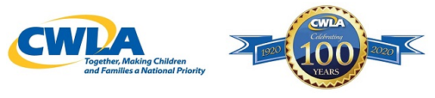
Calling All Caregivers and Parents!
THREE OPPORTUNITIES TO SHARE YOUR VOICE!
New York University, Silver School of Social Work and New York Foundling research project is calling all caregivers! Are you interested in providing feedback about your experience with the child welfare system as a parent? You are invited to participate in a confidential, one-hour phone or video interview. Interviews will be scheduled at your convenience and you will be compensated $50 in the form of an Amazon gift card. If interested, please kindly contact Dr. Darcey Merritt at NYU, Silver School of Social Work at: darceym@gmail.com or 212-998-9186. Please leave your full name and contact information and someone will return your message within 48 hours.

Parents Wanted! Help the New York University, Silver School of Social Work co-design a survey. Are you a parent who has experience with child protective services? We want your feedback on a survey that we're creating. We want to make sure we're asking the right questions. If you: are a Black mother; have experience with child protective services; and have access to a smart phone or computer for an interview, we want to talk to you! Our goal is to find ways to make surveys easy to understand and complete. During the call, we will share some examples with you to get your feedback and ideas to help us design a good survey. The call will be held over video chat for about 90 minutes. You will be compensated $50 for your time. If interested, sign up at bit.ly/3tIuCYw or text 'survey' to 786-309-4766.

The Rutgers University School of Social Work and the New York Foundling research project is calling all caregivers! Are you interested in providing feedback about your experience with the child welfare system and how the COVID-19 pandemic has affected your lives? You are invited to participate in a one-hour phone or video interview. Interviews will be scheduled at your convenience and you will be compensated $50 in the form of an Amazon gift card. If interested, please kindly contact: nyfproject@ssw.rutgers.edu or 848-932-8264. Please be sure to leave your full name, and the best phone number and email address to reach you.
Please share your interest in participating in these opportunities by October 31.

